

**Mini Lab Project Report**

**Voltage Divider and Selector Circuit**

Department: Computer Science and Engineering (CSE)

Semester: Fall 2019

Course Number: CSE109

Course Title: **Electrical Circuits**

Submitted by:

Name Student ID

**Md. Al Amin 2016-3-60-058**

**Nahid Hasan Ashik 2017-2-60-080**

**Md.Subir 2018-1-60-138**

**Submitted to:**

**Rashedul Amin Tuhin**

Senior Lecturer

Department of Computer Science and Engineering

**Group Number: 04**

Date of report submission: **03**-**12-2019**

**Problem Discussion**

A 10V DC supply is available. In practice we need to use 10V, 5V, and 3V as supply voltage of a low current electrical circuit. We have to design a voltage divider circuit so that the desired voltage can be selected at the output.



**Design**

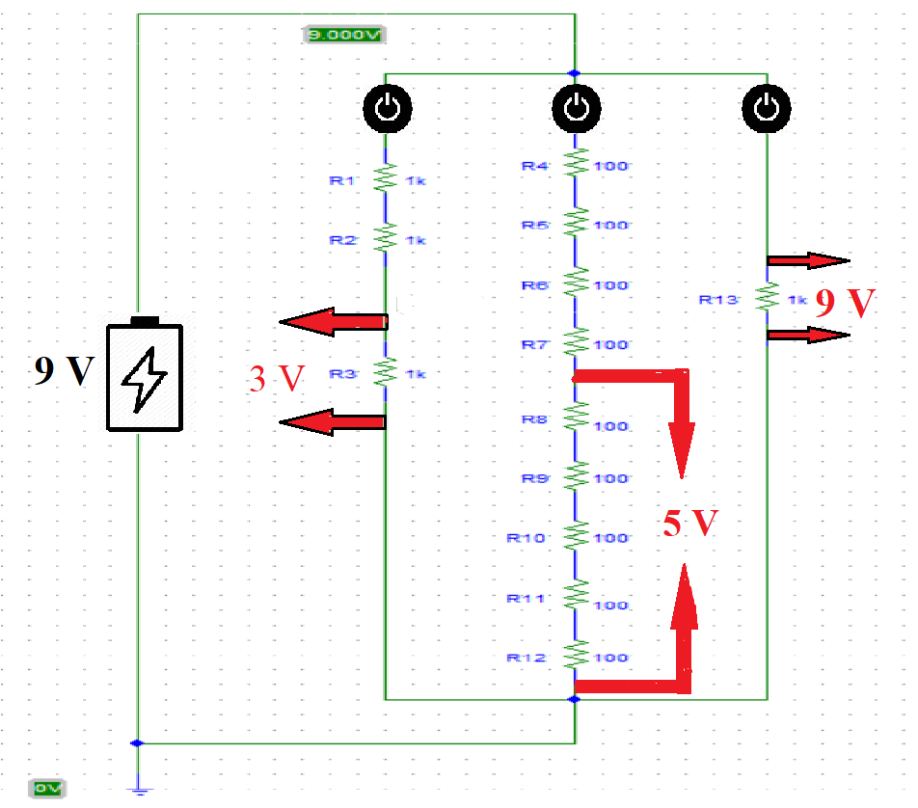

**Figure: 01**

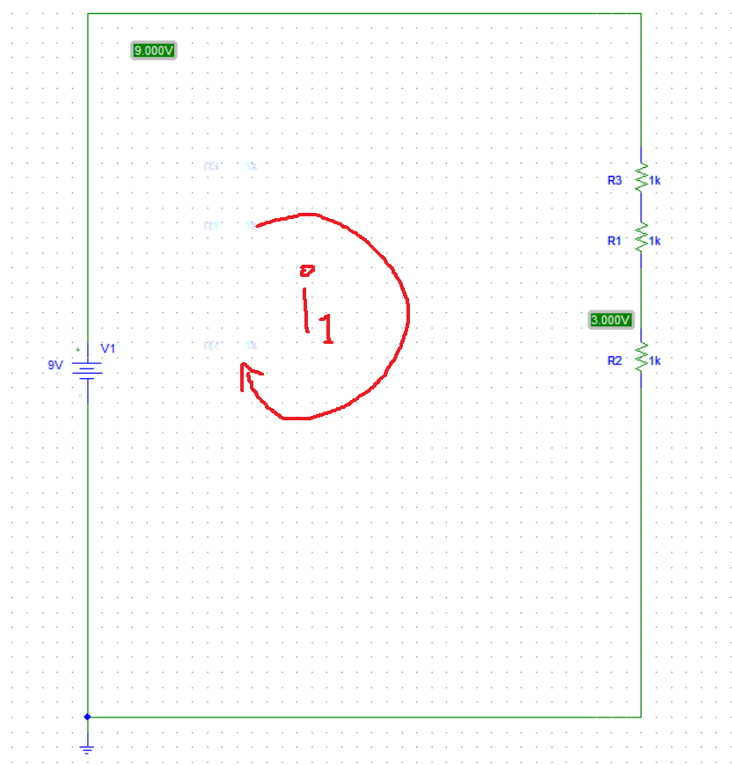

**Figure:2**

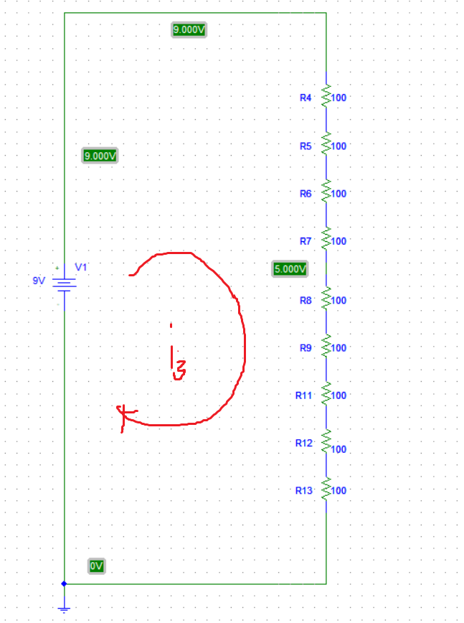

**Figure:3**

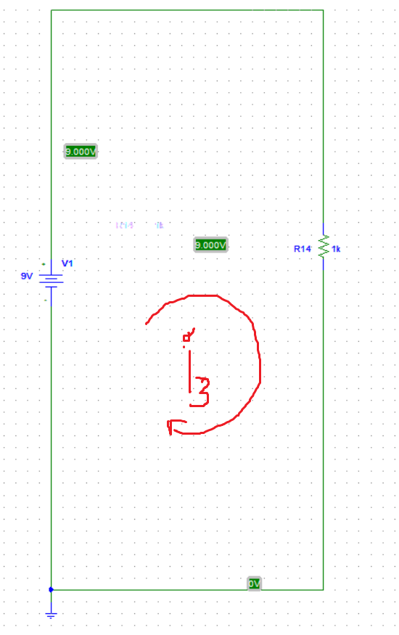

**Figure: 4**

We have use a 9V battery source to concrete the circuit. To find the resistor’s value we first assume the currents i1=3 mA, i2=10mA, i3= 9mAon the figure 2, 3 and 4. And we find the equivalent resistor of those circuit. Then demonstrate those into those circuit.

Here, R1=1000ΩR7=100 Ω

R2=1000 ΩR8=100 Ω

R3=1000 ΩR9=100 Ω

R4=100 ΩR10=100 Ω

R5=100 ΩR11=100 Ω

R6=100 ΩR12=100Ω

R13=1000 Ω

For figure 2, Applying voltage divider rule, we get,

3V=

**→**R3= =1000Ω

So, 3V will be across R3 resistor.

In figure 3, Applying voltage divider rule, we get,

5V=

**→**Rs= =500Ω

So, 5V will be across Rs resistors

Siumilarly 9V will be across R13 resistors.

**Experimental Results**

To get 3 V we have to turn on switch 1 .

Here, Req=(R1+ R2+ R3)=3000Ω

i1=E/ Req= 9/3000=3mA

v1=R3*i1=3*1000=3V

To get 5 V we have to turn on switch 2 .

Here, Req=900Ω

i1=E/ Req= 9/900=10mA

Rs==( R8+ R9+ R10+ R11+ R12)=500Ω

v1=Rs*i1=500*10=5V

Similarly, To get 9 V we have to turn on switch 3 .

Here, Req=1000Ω

i1=E/ Req= 9/1000=9mA

v1=R3*i1=9*1000=9V

|  |  |  |  |
| --- | --- | --- | --- |
| Measured value of E (v) | Measured Value of v1 (V) | Measured Value of v2 (V) | Measured Value of v3 (V) |
| 9.2 | 3.1 | 5 | 9 |

|  |  |  |  |
| --- | --- | --- | --- |
| Name | Theoretically Values | Measured Values | Difference |
| E | 9 | 9.2 | .02 |
| v1 | 3 | 3.1 | .01 |
| v2 | 5 | 5 | 0 |
| v3 | 9 | 9 | 0 |

**Discussion:** Theoretically value and measured value are about same. Negligible differences are found which because of the temperature of the environment where we did the experiment to measure the value.

**Conclusion:** In this experiment project, we had used a 9 V battery. Sometimes because of continuously using the battery , the voltage of the battery could be fallen. So, we can use the adopter source rather than battery to get better result for accurancy.